Sensors

1. DHT 11 Humidity & Temperature Sensor:

DHT11 is a low-cost digital sensor for sensing temperature and humidity.  This sensor can be easily interfaced with any micro-controller such as Arduino, Raspberry Pi etc… to measure humidity and temperature instantaneously. DHT11 humidity and temperature sensor is available as a sensor and as a module. The difference between this sensor and module is the pull-up resistor and a power-on LED. DHT11 is a relative humidity sensor.  To measure the surrounding air this sensor uses a thermistor and a capacitive humidity sensor.

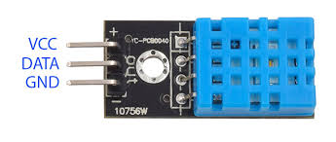

2.MQ-135 GAS SENSOR

The MQ-135 gas sensor senses gases like ammonia nitrogen, oxygen, alcohols, aromatic compounds, sulfide, and smoke. The boost converter of the chip MQ-3 gas sensor is PT1301. The operating voltage of this gas sensor is from 2.5V to 5.0V. The MQ-3 gas sensor has a lower conductivity to clean the air as a gas sensing material. In the atmosphere, we can find polluting gases, but the conductivity of the gas sensor increases as the concentration of polluting gas increases. MQ-135 gas sensor can be implemented to detect the smoke, benzene, steam, and other harmful gases. It has the potential to detect different harmful gases. The MQ-135 gas sensor is a low cost to purchase

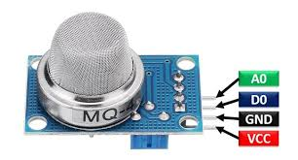

3. KY-026 Flame-sensor

The **KY-026 flame IR sensor** is packed with a photo diode that is sensitive to the spectral range of light that is created by an open flame.  The flame sensor detects wavelengths ranging from 760nm to 1100nm in the infrared spectrum. After detecting a flame, the digital out (DO) line will become **HIGH**.  The analog out (AO) will provide a direct measurement of the reading.

It is not recommend that this device contacts a flame, as the plastic is likely to melt, or combust.  Flame sensor should be kept at a reasonable distance from the source flame.

